DIS-Tanzania-Makonde-Mask

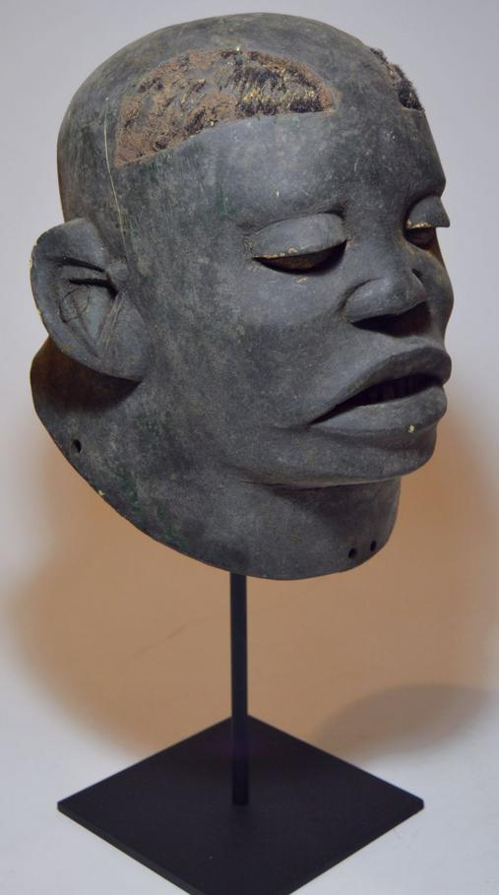 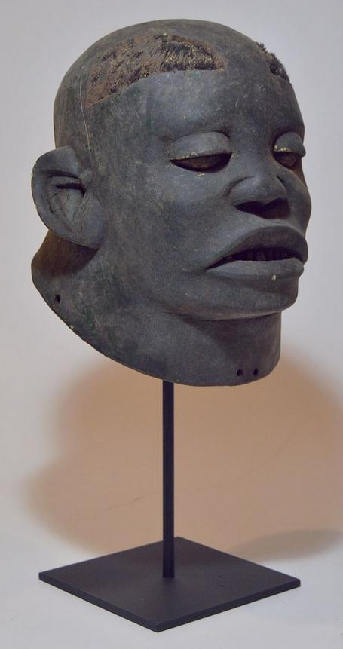 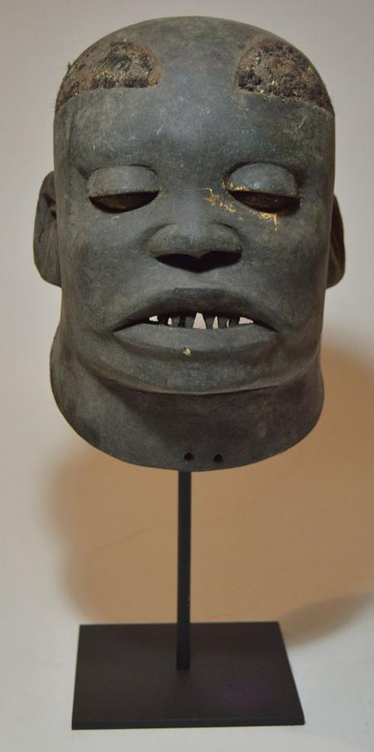 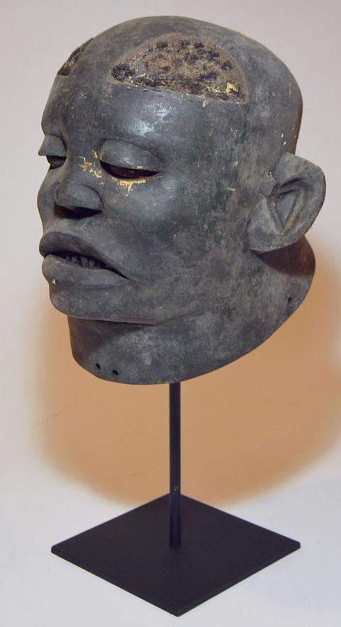 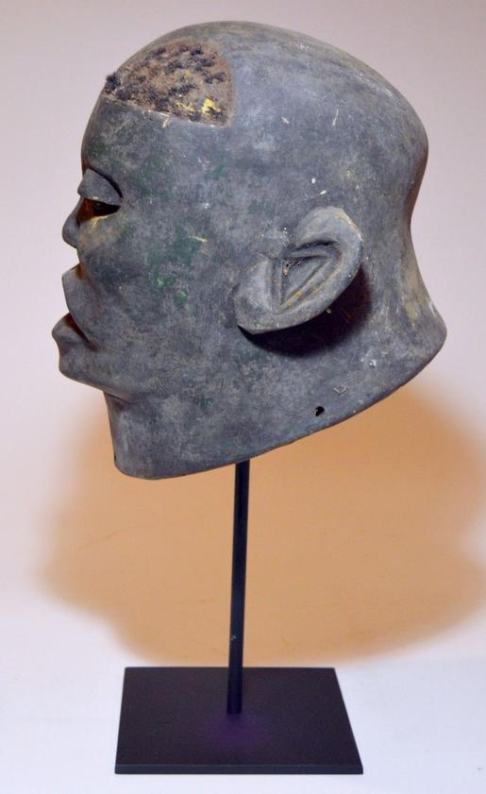 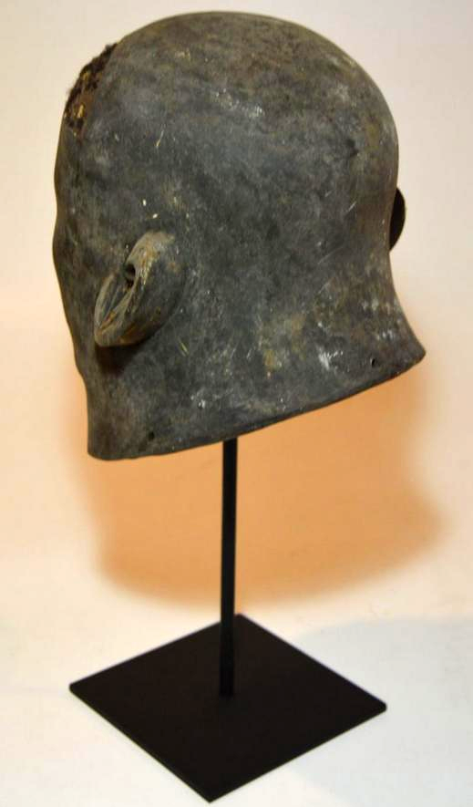

very fine carved wooden mask with a well handled surface patina from the Makonde of Tanzania, East Africa.

The mask itself measures 11 x 8 inches

Sold by [tribal_gathering...](http://myworld.ebay.com/tribal_gatherings) ( [3420](http://feedback.ebay.com/ws/eBayISAPI.dll?ViewFeedback&userid=tribal_gatherings) )

Delivered on Thursday, Nov 3, 2016

#### [A Fine Makonde Lipico African mask on display stand, African Tribal Art](http://www.ebay.com/itm/351883999187)

|  |  |
| --- | --- |
| Item price | $128.00 |
| Quantity | 1 |
| Item number | 351883999187 |
| Shipping service | USPS Parcel Select Ground |

## Shipping address

Ralph J Coffman Jr

149 Atlantic Ave

Swampscott MA 01907-2427

United States

## Order total

|  |  |
| --- | --- |
| Subtotal | $128.00 |
| Shipping | $9.07 |

**Total**

$137.07